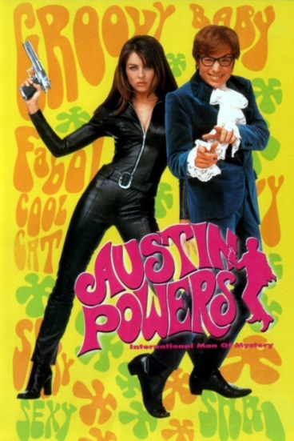
Austin Powers: International Man of Mystery

Name: ………………………………………………………………

- Watch the video and fill in the words that are missing.

1. |  |  | 23.
2. |  |  | 24.
3. |  |  | 25.
4. |  |  | 26.
5. |  |  | 27.
6. |  |  | 28.
7. |  |  | 29.
8. |  |  | 30.
9. |  |  | 31.
10. |  |  | 32.
11. |  |  | 33.
12. |  |  | 34.
13. |  |  | 35.
14. |  |  | 36.
15. |  |  | 37.
16. |  |  | 38.
17. |  |  | 39.
18. |  |  | 40.
19. |  |  | 41.
20. |  |  | 42.
21. |  |  | 43.
22. |  |  | 44.

- Austin Powers is a British secret agent. He works for the government and tries to protect Britain, and the world, from danger. Use the internet to answer these questions.
- The United States have their own secret service, called the United States Secret Service (USSS). What is the British secret service called? .............................................................................................................................
- Next to its original name, the British secret service is also known as MI6. What does this mean and why is it used?
.............................................................................................................................
.............................................................................................................................
- Go to the official website of the British secret service and have a look at the video you can find on their homepage (use your headphones). If you want, you can turn on the subtitles.
What are the two most important tasks of the secret service?
.............................................................................................................................
.............................................................................................................................
How does the secret service try to make sure they succeed in these tasks (4 things)?
.............................................................................................................................
.............................................................................................................................
.............................................................................................................................
.............................................................................................................................
What is their foremost principle?
.............................................................................................................................
.............................................................................................................................

- The Netherlands also have their own secret service. What is ‘our’ secret service called? (Give the full name, don’t use abbreviations)
.............................................................................................................................

When Dr. Evil is unfrozen, he gets a group of criminals together to come up with a new plan to conquer the world. One of these criminals is the ex-Irish assassin Patty O’Brien.

- O’Brien is a superstitious man. What does this mean? Try to explain it in English.
.............................................................................................................................
.............................................................................................................................
- Scotland Yard would love to get their hands on his lucky-charms bracelet as evidence. What is Scotland Yard?
.............................................................................................................................
Where is it located? Give the exact address.
.............................................................................................................................
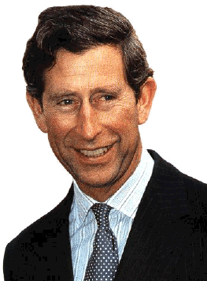
- Dr. Evil has been frozen for 30 years, therefor he missed a lot of things that happened in the world. One of these things is the love affair of Prince Charles.
- With whom did he have an affair?
...............................................................................
- What was her exact title?
...............................................................................
- What are their nicknames for each other?
...............................................................................
- When did they start having their affair and when did they get married?
.............................................................................................................................
.............................................................................................................................
- At the end of the film, Austin hears that he will be knighted by the Queen when he gets back home.
- What does it mean to be knighted by the Queen?
.............................................................................................................................
.............................................................................................................................
- When someone is knighted, the Queen performs the dubbing ceremony. What is this?
.............................................................................................................................
.............................................................................................................................
- Not only British residents can be knighted, people who live in another country can also receive the honour. When can foreign people be nominated for knighthood?
.............................................................................................................................
.............................................................................................................................
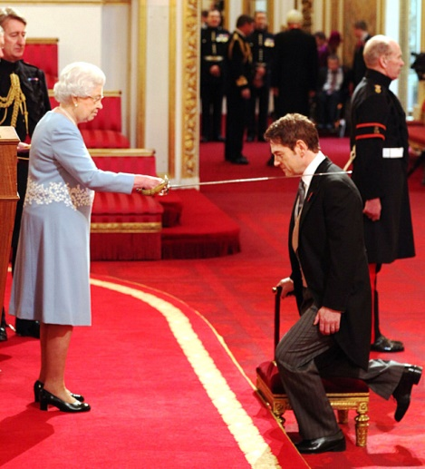
- When a man is knighted, he becomes a ‘Sir’. When a woman is knighted, she becomes a ‘Dame’. Write down three famous Sirs and Dames.
.................................................................................................................................................................................................................................................................................

